RESOLUTION NO.__________

RE: CERTIFICATE OF APPROPRIATENESS UNDER THE
PROVISIONS OF THE ACT OF THE PENNSYLVANIA
LEGISLATURE 1961, JUNE 13, P.L. 282 (53
SECTION 8004) AND BETHLEHEM ORDINANCE NO.
3952 AS AMENDED.

WHEREAS, it is proposed to replace two signs and add a third wall sign at 544 Main Street as well as replacing the blade sign on the Main Street corner.

NOW, THEREFORE, BE IT RESOLVED by the Council of the City of Bethlehem that a Certificate of Appropriateness is hereby granted for the proposal.

Sponsored by: (s)

(s)

ADOPTED BY COUNCIL THIS DAY OF

(s)
President of Council

ATTEST:

(s)
City Clerk

HISTORICAL & ARCHITECTURAL REVIEW BOARD

The applicant is proposing to replace the signage at 544 Main St.
APPLICATION #4:

CSF Buxmont/Judy Happ
P.O. Box 283
Pipersville, PA 18947

OWNER:

__________________________________________________________________________

The Board upon motion by Marsha Fritz and seconded by Connie Glagola adopted the proposal that City Council issue a Certificate of Appropriateness for the following:

- The blade sign will have a pin stripe added to the off-white portion.

- The wall mounted sign at the classroom entrance will also have a pin stripe added.

- The red sign for BuxMont Academy will be mounted in the same location and both the Walnut St. façade sign and the rear entry sign will be painted red to match the letterhead sample with a yellow pin strip and logo added.

- Lettering to be off-white.

- The door panels will be repainted off-white and the red color eliminated from the panel molding.

6. The motion was unanimously approved.
__________________________________________________________________________

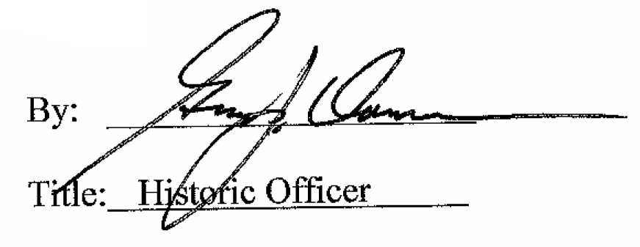

Date of Meeting: September 7, 2016

